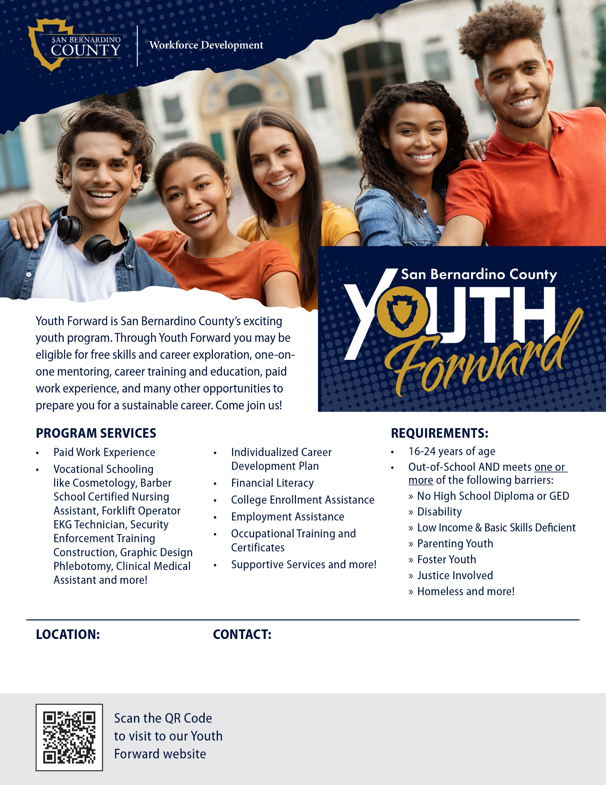


workforce.sbcounty.gov/youth/
Funding for this program is provided by San Bernardino County Workforce Development Board (WDB). This WIOA Title-1 financially assisted program or activity, the WDB, are Equal Opportunity Employers. Auxiliary aids and services are available upon request to individuals with disabilities. For federal funding disclosure information, visit workforce.sbcounty.gov/about/ffd/.

Insert Registration Form Link Here
Contact Info
Website
Organization Name
Address

