WORKFORCE DEVELOPMENT BOARD
EXECUTIVE BOARD SPECIAL MEETING

“Pursuant to the Governor’s Executive Order N-29-20, the Committee meeting was held via teleconference and a publicly noticed location was provided for public observation and comment.”

WEDNESDAY, JANUARY 12, 2022, 8:00 A.M. – 8:30 A.M.
MEETING MINUTES

ATTENDANCE:

Members | Present
Phil Cothran (Chair) | X
William Sterling (1st Vice Chair) | X
B.J. Patterson (2nd Vice Chair) | X
Cinnamon Alvarez | X
Scott Kuethen | X
Jonathan Weldy | X
WDB Staff | Present
Devra Bell | X
Bradley Gates | X

OPENING

- Call Meeting to Order - The Chair called meeting to order at 8:01 AM.
- Introductions – The Board Secretary took roll call attendance.

DISCUSSION

- Re-Adopt Resolution to Participate in Public Meetings via Teleconference
Brad Gates provided an overview of the item to re-adopt the resolution to participate in public meetings via teleconference. If approved, this item will be presented for ratification at the General Board meeting on February 9, 2022. The Chair requested a motion to approve. Will Sterling motioned; Jonathan Weldy seconded the motion. The Board Secretary took a roll call vote. All in favor, non opposed. Item passed.

PUBLIC COMMENT

4) Comments from the General Public - There were no public comments.

ADJOURNMENT

The Chair called for a motion to adjourn. Jonathan Weldy motioned; Will Sterling seconded the motion.

Meeting adjourned 8:09 AM

The next WDB Executive Board Committee meeting is currently scheduled for March 9, 2022 at the WDD Administration Office, 290 North D Street, 6th Floor, San Bernardino, CA 92415.

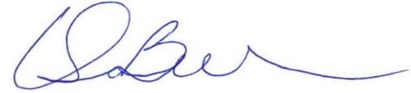
______________________________________
Devra Bell – WDB Secretary

